Sustaining Tenancy Agreement
The purpose of this agreement is to provide a coordinated approach between all parties towards preventing an eviction and assisting a tenant to meet their tenancy obligations
Date of Plan: 14/02/2020
Tenant’s Name:
Tenancy Sustainment Issue:
Action By
Tenant Actions:
Tenant Comments/Outcomes:
CGQ Actions:
CGQ Comments/Outcomes:
Micah Projects Actions:
Micah Projects Comments/Outcomes:

Action By
Initial Review Date:
Review Comments:
Follow Up Review Date:
Review Comments:

Sustaining Tenancy Agreement Closure Date:
Comments at Closure:

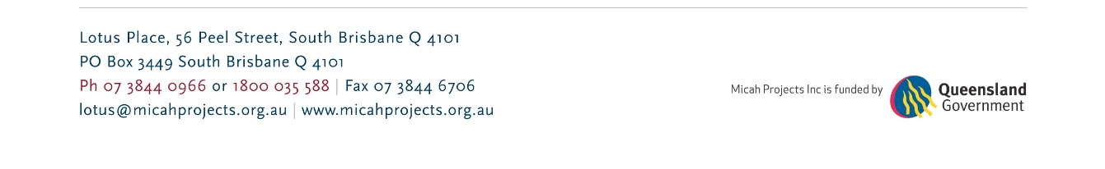
Sustaining Tenancy Agreement – v2 Date Reviewed: 11/02/2020 Page 1 of 1

