Sustaining Tenancies Procedure

Referring Policy: Supportive Housing Policy
Sustaining Tenancies Policy

- Purpose

  - To reduce the likelihood of eviction of a tenant in Common Ground Queensland (CGQ) properties.
  - To work collaboratively with both the on-site Support Provider (Micah Projects) and tenants in an open and transparent manner.
  - To help the tenant identify and address issues impacting on their tenancy.

- Service Coordination Procedure

  - If CGQ or Micah Projects identifies a tenancy is at risk then either party can open a Sustaining Tenancy Plan. Urgent matters should be convened for discussion within 24 hours or the next working day. Non urgent matters should be raised at the weekly Tenant Coordination Meeting (refer Sustaining Tenancies Flowchart).
  - CGQ and Micah Projects decide what action/response is required (e.g. informal discussion, tenant conference, formal correspondence, etc.) and record these actions on the Sustaining Tenancy Plan. If the matter relates to rent arrears CGQ will follow the processes outlined in the Rent Arrears Management Procedure and Rent Calculation, Collection and Review Procedure. A decision will also be made to determine if any follow up with an aggrieved third party is required.
  - Sustaining Tenancy Plans are an internal management tool utilised by CGQ and Micah Projects to identify and manage tenancy sustainment issues. They are reviewed at the weekly Tenant Coordination Meeting.

- Sustaining Tenancy Agreement Procedure

  - If a tenant conference is required, a date and time is arranged with the tenant to meet with CGQ and Micah Projects. Note: there is no mandatory requirement for a tenant to attend this meeting. The Tenancy Manager prepares a Sustaining Tenancy Agreement and/or Repayment Plan Form and compiles any relevant supporting information (e.g. Centrepay Authorisation Form).
  - In instances where the tenant chooses to attend the conference, the issues are discussed and an attempt is made to come to an agreement on how the tenant (with support if required) will manage their tenancy to prevent future issues arising.
  - The Tenancy Manager leads the discussion unless it benefits the conference for Micah Projects to lead the discussion (use Sustaining Tenancy Agreement, and/or Repayment Plan Form).
  - Actions agreed upon must be tangible, achievable and designed to address issues which may cause tenancy breaches to occur (e.g. seeking domestic services for maintaining unit).
  - CGQ, Micah Projects and the tenant agree to a review date which is noted on the Sustaining Tenancy Agreement. The tenant may wish to sign and/or have a copy of the Sustaining Tenancy Agreement and/or Repayment Plan Form.
  - Sustaining Tenancy Agreements are closed when all parties agree that the issue has been resolved or when CGQ and Micah Projects believe it has been unsuccessful and alternative action is necessary (refer Section 2.10).

- Formal Action Procedure

  - If the tenant refuses to take part in a conference or refuses to agree to the conditions outlined in the Sustaining Tenancy Agreement and/or Repayment Plan Form AND continues to behave in a manner that negatively impacts their tenancy, the Tenancy Manager may decide to issue a Notice to Remedy Breach (RTA Form 11) or take alternative action (i.e. visitor restriction, etc.). Alternatively CGQ may require the tenant to enter into an Acceptable Behaviour Agreement as per Section 527D of the Residential Tenancies and Rooming Accommodation Act 2008 (RTRAA).
  - In instances where an Acceptable Behaviour Agreement is initiated, CGQ, Micah Projects and the tenant will agree to a review date which is noted on the agreement. Acceptable Behaviour Agreements are closed when all parties agree that the issue has been resolved or when CGQ and Micah Projects believe it has been unsuccessful and alternative action is necessary (refer Section 2.12).
  - Terminating the tenancy is used as a last resort when all other efforts have failed and will be carried out in accordance with the RTRAA (refer Ending a Tenancy Procedure). In all instances where a tenancy may be terminated, the Tenancy Manager must consult with the Chief Executive Officer (CEO) and obtain approval to initiate action. CGQ will inform Micah Projects prior to issuing the tenant with a Notice to Leave (RTA Form 12) or notification that CGQ has initiated a QCAT application.

- Referenced Documents

Acceptable Behaviour Agreement
Centrepay Authorisation Form
Ending a Tenancy Procedure
Notice to Leave (RTA Form 12)
Notice to Remedy Breach (RTA Form 11)
Rent Arrears Management Procedure
Rent Calculation, Collection and Review Procedure
Repayment Plan Form
Sustaining Tenancy Agreement
Sustaining Tenancy Plan
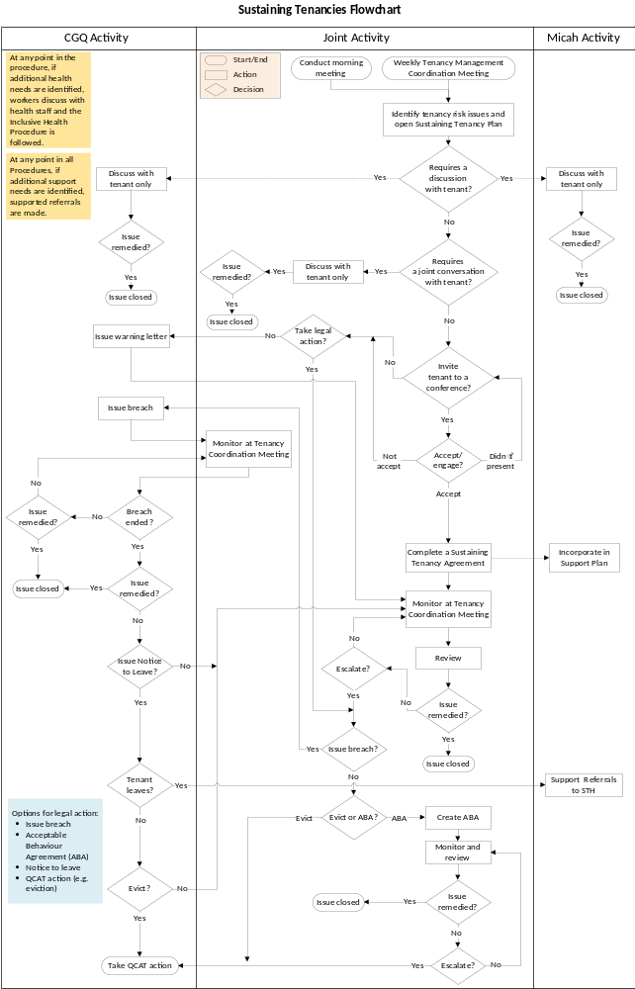

The purpose of the Tenant Coordination Meeting is to provide a coordinated and planned approach to prevent tenant evictions and to assist tenants in sustaining their tenancies.
Queensland Civil and Administrative Tribunal (QCAT)

